Data Structures Prefinal Exam

1. Using a while loop, write a java program that will ask a number from the user and print the sum of the numbers.

Enter n: 5

Sum is: 15

Sum is 15 because 1+2+3+4+5 = 15.

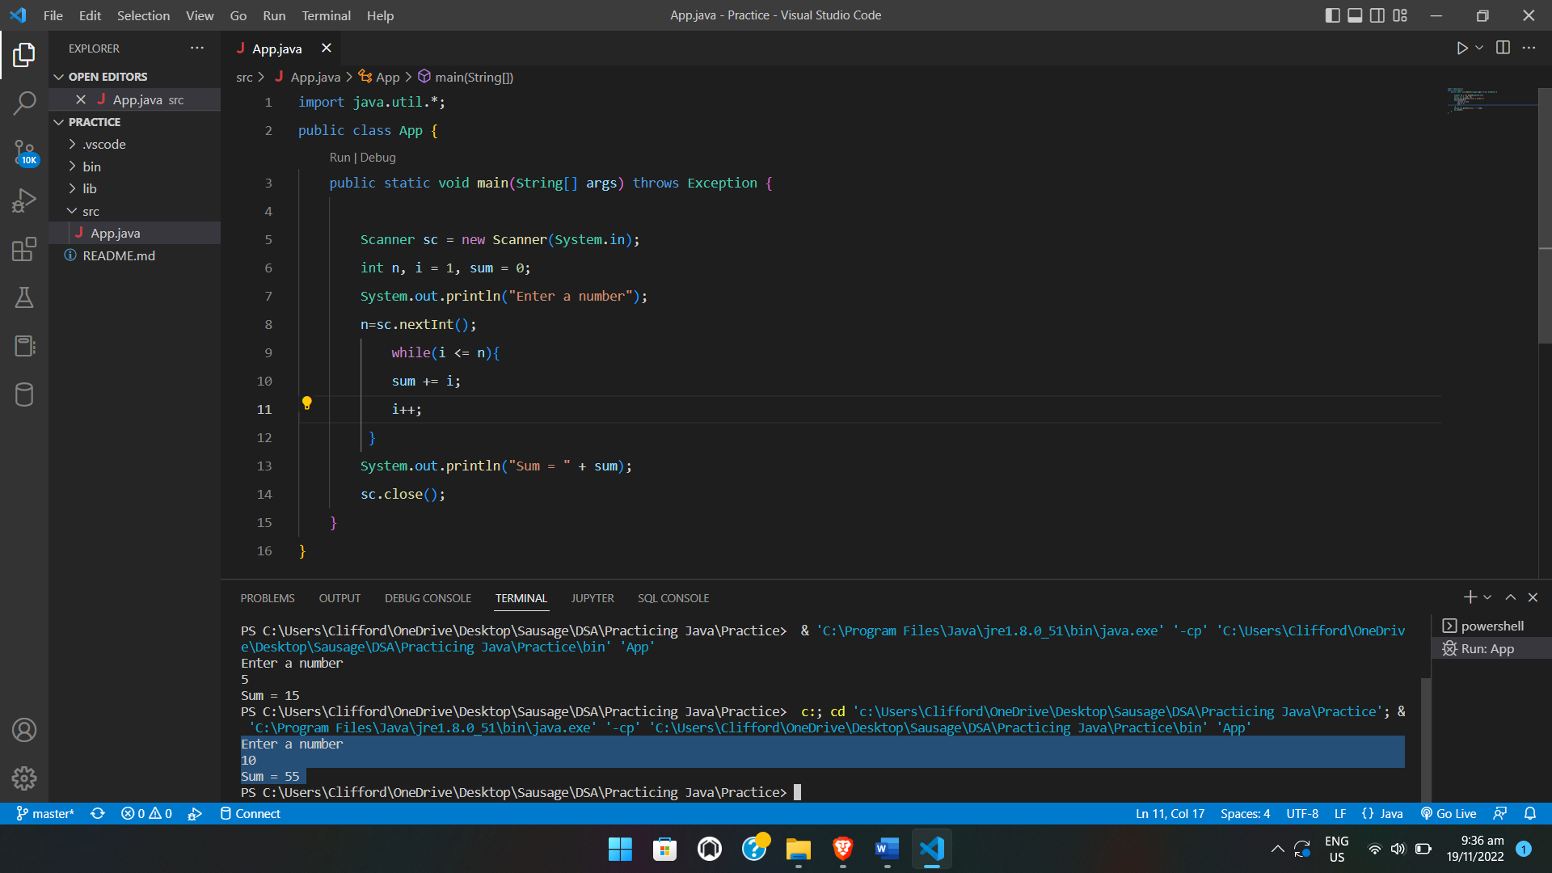

1. Using a for loop, write a java program that will ask for a number from a user and print a triangular shape with a base depending on the number, please refer to below output.

Enter n: 5

Output

Note: There are spaces before the asterisk, it depends on the number entered by the user. For the first asterisk the number of spaces is 4 and the 2 asterisks, the number of spaces is 2 and so on.

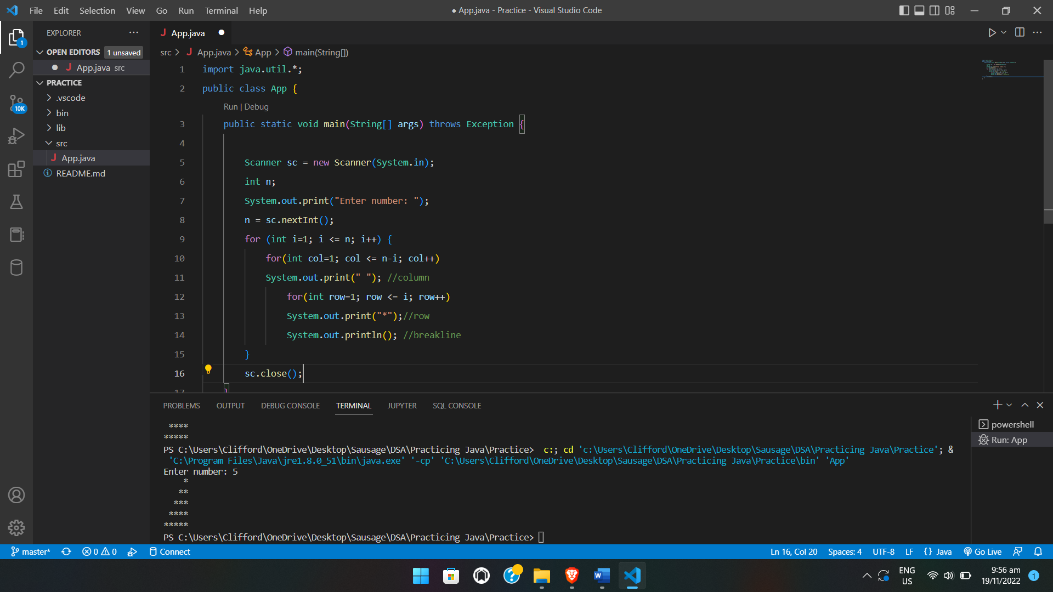

1. Using a for loop, write a java program that will ask for a start year and end year from a user and print all years that are not leap years. Any year divisible by 4 is a leap year.

Enter start year: 2021

Enter end year: 2022

Output

Print a 2021

Print b 2022

Note: Years are not divisible by 4 hence added in the output.

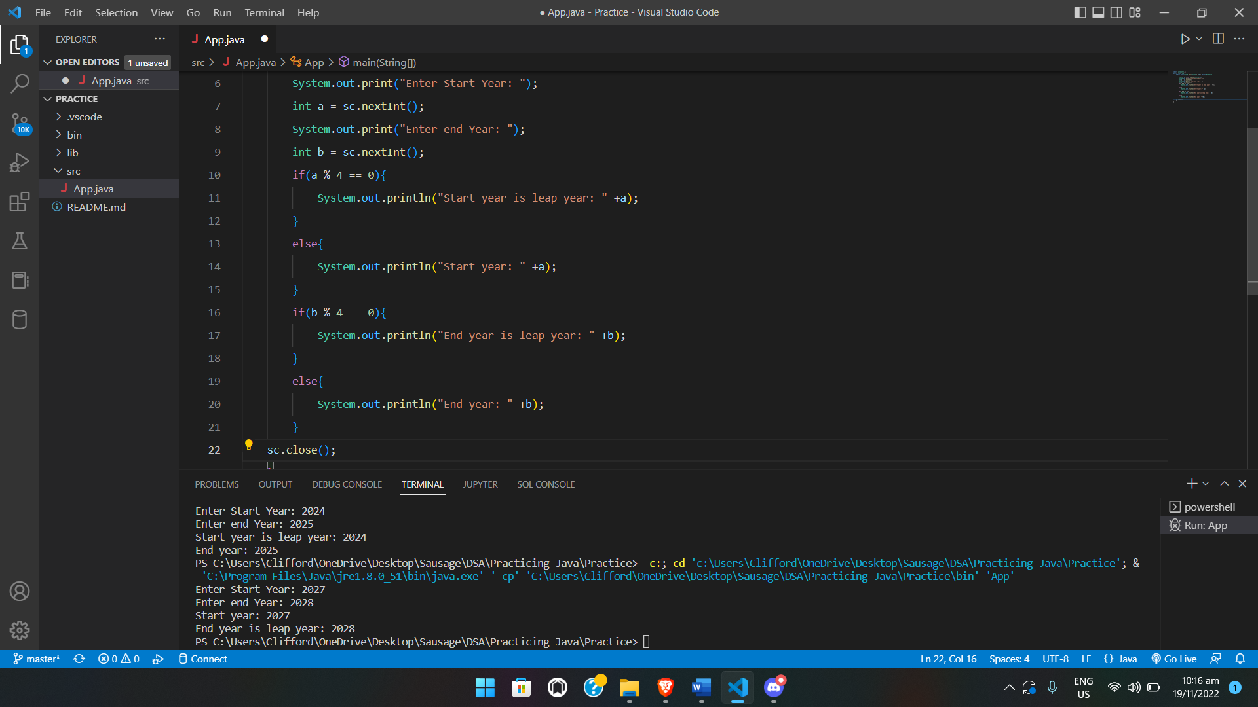

**Note:** Please put the codes in a word file and save the file following the format <Lastname Firstname>-DSA-Prefinal (e.g., Beldad Mark Joseph-DSA-Prefinal) and send it to [mbeldad@tfvc.edu.ph](mailto:mbeldad@tfvc.edu.ph) via email.